**Designing a scalable, efficient, and well-structured database for a To-Do App requires careful planning. Below are key insights that ensure data integrity, performance, and flexibility.**

**1. IDENTIFY CORE ENTITIES**

**A To-Do App typically involves the following key entities:**

1. Users → Manages user authentication and personalization.

2. Tasks → Stores the actual to-do items.

3. Labels (Tags) → Organizes tasks into categories.

4. Task Reminders → Manages notifications for due tasks.

5. Subtasks (Optional) → Supports hierarchical task management.

**2. DATABASE SCHEMA DESIGN PRINCIPLES**

**a. Use Normalization to Reduce Redundancy**

* Separate users and tasks to avoid duplicating user data.
* Use a Many-to-Many relationship for labels (via a linking table).
* Store timestamps for tracking changes (e.g., created_at, updated_at).

**b. Optimize for Performance**

* Index foreign keys (user_id, task_id) to speed up lookups.
* Use ENUM for status fields (e.g., "pending", "completed").
* Denormalization for analytics (e.g., store "task count per user" in Users table).

**c. Ensure Data Integrity & Consistency**

* Use Foreign Keys for relationships to maintain referential integrity.
* Use ON DELETE CASCADE to remove related tasks when a user deletes their account.
* Use UUIDs instead of auto-incremented IDs for better security in a distributed system.

**Recommended Database Schema (SQL Example)**

**USERS TABLE (**STORES USER INFORMATION.)

CREATE TABLE Users (

id INT PRIMARY KEY AUTO_INCREMENT,

username VARCHAR(50) UNIQUE NOT NULL,

email VARCHAR(100) UNIQUE NOT NULL,

password_hash VARCHAR(255) NOT NULL,

created_at TIMESTAMP DEFAULT CURRENT_TIMESTAMP,

updated_at TIMESTAMP DEFAULT CURRENT_TIMESTAMP ON UPDATE CURRENT_TIMESTAMP

);

**TASKS TABLE (**STORES TASK DETAILS.)

CREATE TABLE Tasks (

id INT PRIMARY KEY AUTO_INCREMENT,

user_id INT NOT NULL,

title VARCHAR(255) NOT NULL,

description TEXT,

status ENUM('pending', 'completed', 'archived') DEFAULT 'pending',

priority ENUM('low', 'medium', 'high') DEFAULT 'medium',

due_date DATETIME DEFAULT NULL,

created_at TIMESTAMP DEFAULT CURRENT_TIMESTAMP,

updated_at TIMESTAMP DEFAULT CURRENT_TIMESTAMP ON UPDATE CURRENT_TIMESTAMP,

FOREIGN KEY (user_id) REFERENCES Users(id) ON DELETE CASCADE

);

**TASK LABELS (TAGS) TABLE**

For task categorization.

CREATE TABLE Labels (

id INT PRIMARY KEY AUTO_INCREMENT,

user_id INT NOT NULL,

name VARCHAR(50) NOT NULL,

FOREIGN KEY (user_id) REFERENCES Users(id) ON DELETE CASCADE

);

**Task-Label Relationship Table**

A **Many-to-Many relationship** between Tasks and Labels.

CREATE TABLE Task_Label_Map (

task_id INT NOT NULL,

label_id INT NOT NULL,

PRIMARY KEY (task_id, label_id),

FOREIGN KEY (task_id) REFERENCES Tasks(id) ON DELETE CASCADE,

FOREIGN KEY (label_id) REFERENCES Labels(id) ON DELETE CASCADE

);

**REMINDERS TABLE (OPTIONAL) FOR TASK REMINDERS.**

CREATE TABLE Reminders (

id INT PRIMARY KEY AUTO_INCREMENT,

user_id INT NOT NULL,

task_id INT NOT NULL,

notification_time DATETIME NOT NULL,

status ENUM('pending', 'sent') DEFAULT 'pending',

FOREIGN KEY (user_id) REFERENCES Users(id) ON DELETE CASCADE,

FOREIGN KEY (task_id) REFERENCES Tasks(id) ON DELETE CASCADE

);

**4. Additional Optimizations**

**✅ Indexes for Faster Query Performance**

CREATE INDEX idx_tasks_user ON Tasks(user_id);

CREATE INDEX idx_task_due_date ON Tasks(due_date);

**✅ Views for Quick Data Retrieval**

Create a **view** to quickly fetch pending tasks per user.

CREATE VIEW pending_tasks AS

SELECT t.id, t.title, t.status, t.due_date, u.username

FROM Tasks t JOIN Users u ON t.user_id = u.id

WHERE t.status = 'pending';

**✅ JSON Storage (For NoSQL or Hybrid Approach)**

If using **MongoDB**, store tasks in a document-based format:

json

{

"_id": "task_id",

"user_id": "user_id",

"title": "Task Title",

"description": "Optional",

"status": "pending",

"priority": "medium",

"due_date": "2025-02-01T12:00:00Z",

"labels": ["work", "urgent"]

}

SCHEMA TABLE FOR TO-DO-APP (FRONT END DEVELOPMENT)

Database Schema (Frontend To-Do App)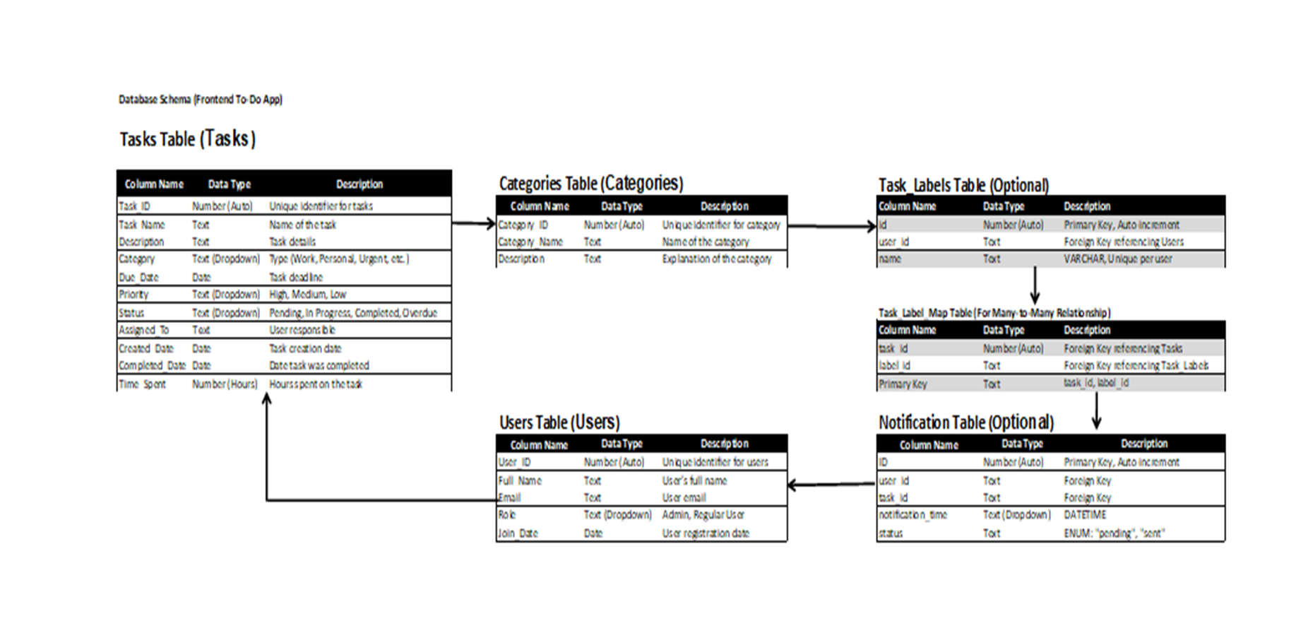

Here’s an **Entity-Relationship Diagram (ERD)** for a **To-Do App**. It visually represents how the database tables are related.

### **Entities & Relationships in the ERD**

1. **Users** → Users who manage their tasks.
   * *One-to-Many*: A user can have multiple tasks.
2. **Tasks** → To-do items created by users.
   * *Many-to-One*: Each task belongs to one user.
   * *Many-to-Many*: Tasks can have multiple labels.
3. **Labels (Tags)** → Categories for tasks.
   * *Many-to-Many*: A label can be assigned to multiple tasks.
4. **Task_Label_Map** → Junction table for tasks and labels.
   * *Bridges Many-to-Many* between Tasks and Labels.
5. **Reminders (Optional)** → Task notification system.
   * *One-to-One*: A task can have a reminder.

### **ERD Diagram Representation**

lua

+------------+ 1 +---------+ M +-----------+ M +------------+

| Users |-------->| Tasks |-------->| Task_Label |------| Labels |

+------------+ +---------+ +-----------+ +------------+

| id (PK) | | id (PK) | | task_id (FK) | | id (PK) |

| username | | user_id (FK) | | label_id (FK)| | name |

| email | | title | +-----------+ +------------+

| password | | status |

+------------+ | due_date |

+---------+

+-------------+

| Reminders |

+-------------+

| id (PK) |

| user_id (FK)|

| task_id (FK)|

| time |

+-------------+

### **Explanation**

1. **Users (PK: id)**
   * Stores user authentication details.
2. **Tasks (PK: id, FK: user_id)**
   * Each task belongs to a single user.
3. **Labels (PK: id, FK: user_id)**
   * Users can create their own task labels.
4. **Task_Label_Map (PK: task_id, label_id)**
   * Resolves the Many-to-Many relationship between Tasks and Labels.
5. **Reminders (PK: id, FK: task_id, user_id)**
   * A user can set a reminder for a specific task.

## **Essential Features for a To-Do App**

### **✅ Task CRUD Operations**

* Add, edit, delete, and mark tasks as complete/incomplete.
* **Optimistic UI updates** (update UI before API response).

### **✅ Task Organization Features**

* **Categories or Labels** (Work, Personal, Urgent, etc.).
* **Task Priority Levels** (Low, Medium, High).
* **Task Due Dates & Reminders** (with calendar picker).

### **✅ Task Filtering & Sorting**

* **Search bar** to find tasks quickly.
* **Sort by:** Due Date, Priority, Completion Status.

### **✅ Real-Time Syncing (Optional)**

* Use **WebSockets** or **Firebase** for real-time task updates.

## **State Management & Performance Optimization**

### **✅ State Management Approaches**

* **Small-Scale App:** Use **React Context API** for global state.
* **Large-Scale App:** Use **Redux Toolkit** or **Zustand**.

### **✅ Performance Optimization**

* **Lazy load components** (Code splitting with React.lazy).
* Use **Debouncing** for input fields to reduce API calls.
* **Cache API requests** using SWR or React Query.

## **API & Backend Integration Best Practices**

### **✅ Efficient API Calls**

* **Use RESTful APIs** (or GraphQL for complex queries).
* **Batch API calls** instead of sending multiple requests.
* **Cache task data** locally using IndexedDB or localStorage.

### **✅ Authentication**

* **JWT Tokens** for secure user authentication.
* **OAuth (Google/Facebook login)** for quick sign-in.

## **Deployment & Hosting Recommendations**

* **Frontend Hosting:** Vercel, Netlify, Firebase Hosting.
* **Backend Hosting:** Render, DigitalOcean, Heroku, AWS.
* **Database:** Firebase Firestore (NoSQL), PostgreSQL (SQL).

## **Additional Enhancements**

🚀 **AI-Powered Task Suggestions** → Suggest deadlines based on task type.  
🚀 **Recurring Tasks** → Automatically repeat tasks (daily, weekly).  
🚀 **Voice Input Support** → Use Web Speech API for task input.  
🚀 **PWA Support** → Make the app installable on mobile & desktop.